Patrick Harrington
CS-405 Secure Coding
Southern New Hampshire University
May 10, 2026
1-3 Activity: Numeric Overflow Coding
Console Output and Process Summary
Summary of Process
For this assignment, I modified the add_numbers() and subtract_numbers() template functions so they detect overflow and underflow before performing arithmetic. The add_numbers() function checks whether the next addition would exceed std::numeric_limits<T>::max(). If the operation would exceed the maximum value, the function returns std::nullopt instead of allowing the overflow to happen.
The subtract_numbers() function checks whether the next subtraction would go below std::numeric_limits<T>::lowest(). I used lowest() instead of min() because min() behaves differently for floating-point numbers. For floating-point types, min() represents the smallest positive normalized value, while lowest() represents the lowest possible value.
Both functions now return std::optional<T>. When the operation succeeds, the result is returned. When an overflow or underflow would occur, std::nullopt is returned. The test_overflow() and test_underflow() functions were updated to check whether the function returned a valid result. If no valid result was returned, the program prints that the operation was prevented and displays the overflow or underflow status as true.
One issue I encountered was that VS Code showed red squiggly lines even though the program compiled and ran successfully in the terminal. I verified the program by compiling it with clang++ using the C++17 standard and running the executable. The console output confirmed that the overflow and underflow tests completed successfully.
Build and Run Commands Used
clang++ -std=c++17 NumericOverflows.cpp -o NumericOverflows
./NumericOverflows

Screenshot 1: Application running in VS Code with the initial overflow test output.
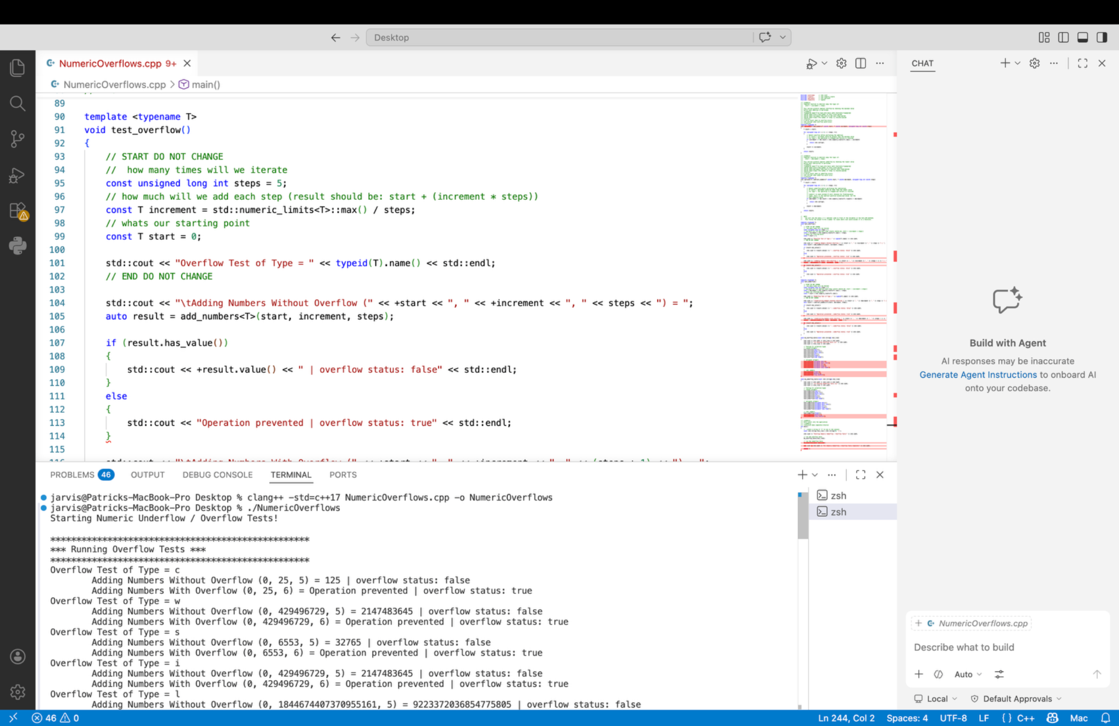

Screenshot 2: Console output showing overflow checks and the beginning of underflow checks.
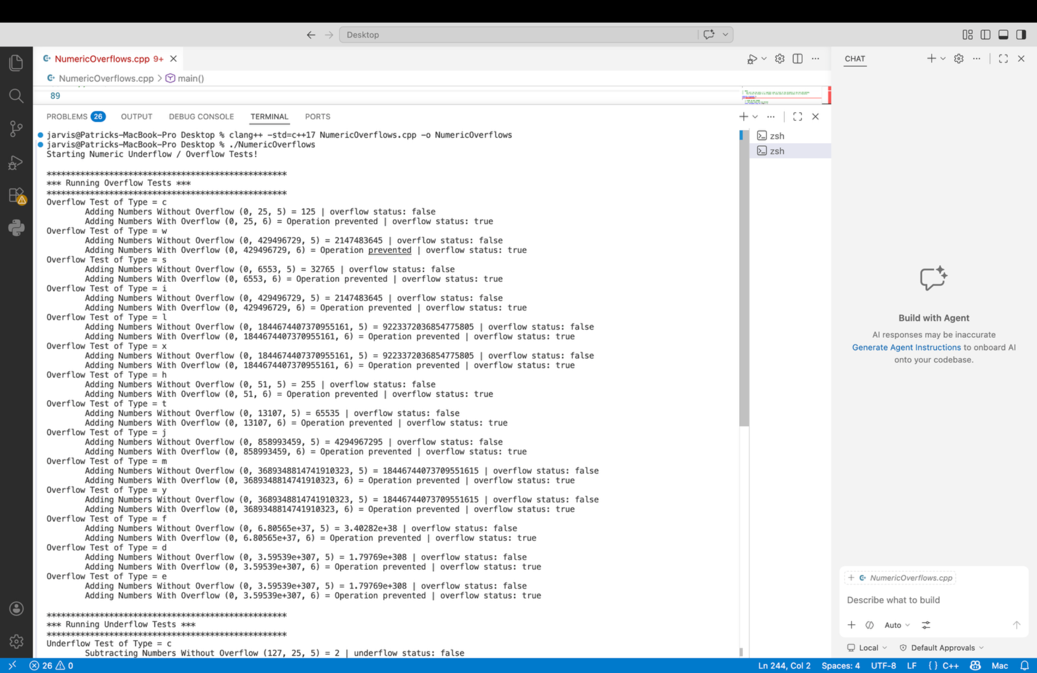

Screenshot 3: Console output showing underflow checks and the completion message.
